9th International Conference on Ambient Systems, Networks and Technologies, ANT-2018 and the 8th International Conference on Sustainable Energy Information Technology,

SEIT 2018, 8-11 May, 2018, Porto, Portugal

Industrial Communication based on Modbus and Node-RED

Mohamed Tabaa*, Brahim Chouri, Safa Saadaoui, Karim Alami

**Abstract**

Over the next few years, the Industrial Wireless Sensor Network (IWSN), which is a major part of the Industrial Object Internet (IIoT), will play a crucial role in transforming the industrial world by opening a new era of economic and competitive growth in the Industrial Revolution known as "Industry 4.0". IIoT is able to help organizations achieve better benefits in industrial manufacturing markets by increasing productivity, reducing costs and developing new services and products. In this paper we present a wireless industrial communication system based on Node-RED platform using Modbus protocol for smart factories.

© 2018 The Authors. Published by Elsevier B.V.

Peer-review under responsibility of the Conference Program Chairs.

*Keywords:* industrial communication, Industry 4.0, Node-RED, MODBUS, IIOT, MQTT.

# Introduction

In 1980, the 3rd Industrial Revolution was the cause of a huge evolution of the industrial world. This evolution has been accompanied by network complexity that exceeds the reliability and strength of automation systems. Thus, the need to find a more comprehensive means of information exchange, which can ensure interconnection on a wider and more refined scale2,4,5. Today, with the new technology, the gateway to the 4th Industrial Revolution, known as Industry 4.0, makes it possible to add intelligence to industrial systems based on interconnected physical or virtual objects, capable of communicating and transmitting information in a less-complex way. This, with less error, based on two main strategies, the Internet of Things (The Internet Of Things, IoT) and Cyber Physical Systems (CPS) 3,7.

Industrial wireless sensor networks (IWSN) have several advantages, including reducing the cost of deploying and building a controlled workspace. By installing IWSNs on workstations and attaching labels to current products, information about production operations can be collected efficiently and flexibly, and cyber-physical decisions can be made instantly with great accuracy1,2,4.

To make manufacturing operations more agile, more flexible, more responsive to customer needs and to promote competitive advantages, industrial companies intend to rely on the fourth industrial revolution for more automation and flexibility. With industry 4.0, it is now possible to create an intelligent factory where wireless sensors and many other advanced technologies are used. These tools enable the company to react more quickly to market changes and thus optimize production and improve customer satisfaction4,7,9.

With this paper we are particularly interested in the application of the Internet of things in the industrial field especially for smart factories wireless communication. We aim to replace all the heavy wiring in the factories with an intelligent and agile system based on smart things and smart communication for control and monitoring. We present in this paper an industrial communication based on Node-RED Framework using Modbus protocol and MQTT protocol.

This article is organized as follow: in section 2 we present a state-of-art of industry 4.0. , the strategy of cyper- physical system in industry will be presented in section 3. In section 4, we present the main objective of IoT in industrial application. Implementation with Node-RED and all discussion will be presented in section4. Finally, conclusion and perspectives.

# Industry 4.0

In the context of industry 4.0 and intelligent manufacturing, it is essential to support factory automation as well as flexibility in industrial environments that are considered difficult environments for wireless communication due to high noise, physical barriers, multi-path and interference from co-existing wireless devices1,3,6. The industry 4.0 concept designates the use of digital technologies and consists of building a controlled workspace using a large-scale deployment of wireless sensors. Introducing digital technologies into a manufacturing company requires building a digital factory to create digital products and provide a digital customer experience.

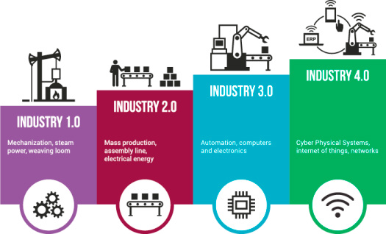The strength of Industry 4.0 lies in the integration of human, machine and systems at the same time. It is not yet clear how future developments will actually progress; the results of research in this direction still cannot tell when the era of automation will end.

Fig.1. Industry 4.0

Today, it is the largest projects that drive the debate on industry 4.0, its future projections and the different long- term visions. According to the researchers, we will have to wait at least ten years to see the deployment of this revolution's technologies. The journey from the era of automation to the era of industry 4.0 is not so obvious, training needs to be put in place, new standards, costly installations and high investment requirements, basically a new ground with new ground rules. Overall, it can also be assumed that the individual elements of industry 4.0 will

be carried out on a larger scale in subsequent stages. Automated systems will continue to play a central role in production control over the next five years. However, they will have to meet additional requirements such as providing data for new business models and exchanging information online with other operational systems. The merging of virtual and physical worlds with cyber-physical systems and the resulting fusion of technical and business processes paves the way for a new industrial era better defined by the concept of the intelligent factory4,5.

# Cyber-Physical Systems in Industry 4.0

Industrial sectors, the automotive industry, energy saving and, in particular, production technology will be transformed by new value chain models. Globalization, urbanization, demographic change and energy transformation are the transformative forces that stimulate the technological impulse to identify solutions for a world in flux. In the future, industry 4.0 will make contributions to human safety, efficiency, comfort and health in a way that is not imagined before. In doing so, they will play an important role in tackling the fundamental challenges posed by demographic change, scarcity of natural resources, sustainable mobility and energy change1,3,7.

The deployment of cyber-physical systems in production systems gives birth to the intelligent factory (Fig.2.). Intelligent plant products, resources and processes are characterized by cyber-physical systems. Offering significant real-time benefits in terms of quality, time, resources and costs compared to conventional production systems. The Smart Factory is designed according to sustainable, service-oriented business practices. These insist on adaptability, flexibility, self-adaptability and learning characteristics, fault tolerance and risk management, which shows that the application of the Industry 4.0 concept necessarily implies optimizing the cost and time of production, and thus a large margin of gain that could contribute to industrial development.

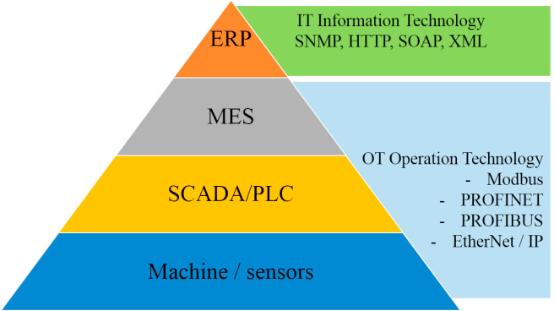

Fig.2. Cyper-Physical System in industry

# Industrial Internet of Thing

The Internet of Things (IoT) is a system of interdependent computer peripherals, machines, sensors, objects, animals or people with unique identifiers that can transmit and receive data over a network, without human intervention or computer interaction. It is the network interconnection of objects equipped with ubiquitous intelligence that has evolved from the convergence of wireless technologies, micro-electromechanical systems (MEMS), micro-services and the Internet. It also analyzed the data generated by unstructured machines to provide information2,4,6.

Practical applications of IoT technology are now found in many industries, including agriculture, chemicals, pharmaceuticals and petroleum, health, energy and transportation. The Industrial Internet of Things (IoT), which is the industrial application of IoT in industry, opens huge opportunities for a large number of new applications that promise to improve productivity in factories, and ensure a better allocation of resources. This revolutionary

technology is attracting increasing attention from researchers and practitioners around the world. The set of protocols in the Internet of Things represents a language common to all connected systems, whatever their brand, operating system or software tools used. Table 1 shows the famous technologies used for IoT.

Table 1. Communication technology

|  |  |  |  |  |
| --- | --- | --- | --- | --- |
| Technology | Standard | Frequency | Range | Transmission speed |
| Bluetooth | Bluetooth 4.2 | 2,4 GHz (ISM) | 50-150 m  (Smart/BLE) | Mbit/s (Smart/BLE) |
| Zigbee | IEEE802.15.4 | 2,4 GHz | 10-100 m | 250 Kbit/s |
| Z-wave | Z-Wave Alliance ZAD12837/ITU-T G.9959 | 900MHz (ISM) | 30 m | 9,6 / 40 / 100  Kbit/s |
| 6lowPan | RFC6282 | 2,4 GHz | -- | -- |
| Wifi | 802.11n | 2,4 GHz and 5 GHz | 50m | 600 Mbit/s max |
| Sigfox | Sigfox | 900 MHz | 30-50 km (E  ruraux), 3-10 km (E urbains) | 10-1 000 bit/s |
| LoRa | LoRa | 3 frequencies | 15 km | 0,3-50 Kbit/s |

# Wireless Industrial Communication based on NodeRed

Industry 4.0 draws the intention on an application scenario that consists in building or forming a network of plants distributed geographically by using a flexible adaptation of the production and resource sharing capacities that ensures a wide and secure communication. In this session we are developing our distributed architecture of industrial systems based on Node-Red and Modbus.

* 1. *Context*

The implementation of industry 4.0 requires the adaptation of new methodologies and technologies. The industrial ecosystem is limited to installations wired between all sensors and actuators, based on a set of industrial protocols: Modbus, profibus, valve and others. In our architecture, we opted for the Modbus protocol. This is a dialogue protocol based on a hierarchical structure between a master and several slaves, as shown in the figure 3.

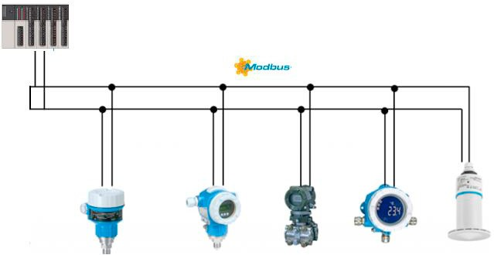The integration of IoT in the industrial field requires the use of wireless sensor-actuator networks that operate in real time for cyber-physics industrial systems, and when talking about cyber-physics systems we are faced with a wireless control system that includes several control loops that connect sensors, controllers and actuators via a wireless mesh network..

Fig.3.Industrial Modbus communication

* 1. *Discussions*

To test this industrial wireless communication in the form of a network of connected objects, the IoT device integration layer has been added to the software infrastructure. This layer consisted of virtual nodes (simulated MQTT clients) and industrial communication architecture based on Node-RED and Modbus protocol. To add a node to the system, its identifiers must be registered with the broker MQTT. Virtual nodes, nodes for the sole purpose of simulating communication flows (Master-Slave) in the system, were simulated using client-mqtt libraries. Figure 4 shows a virtual node created for sending information in the Modbus frame-responsive form to a Windows machine.

Network connectivity was provided by a single on-board computer via MODBUS frame exchange. A gateway has been set up to read/write MODBUS registers and transmit/receive messages via MQTT broker. The figure 5 shows the reception of the data via the gateway as well as the nature of the frame used and the figure shows the implementation of a node flow on the gateway. The gateway accessed the MODBUS over a wireless network to read its registers, then reformulate and send data to the external message broker via MQTT managed by AMQP Cloud. The exchange of information between the master and all slaves via MQTT and modbus is shown in Figure 6.

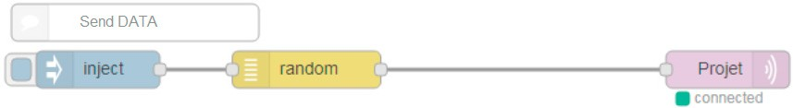

Fig.4. Sending information

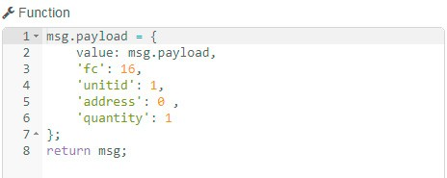

Fig.5.reception of information and distribution among slaves

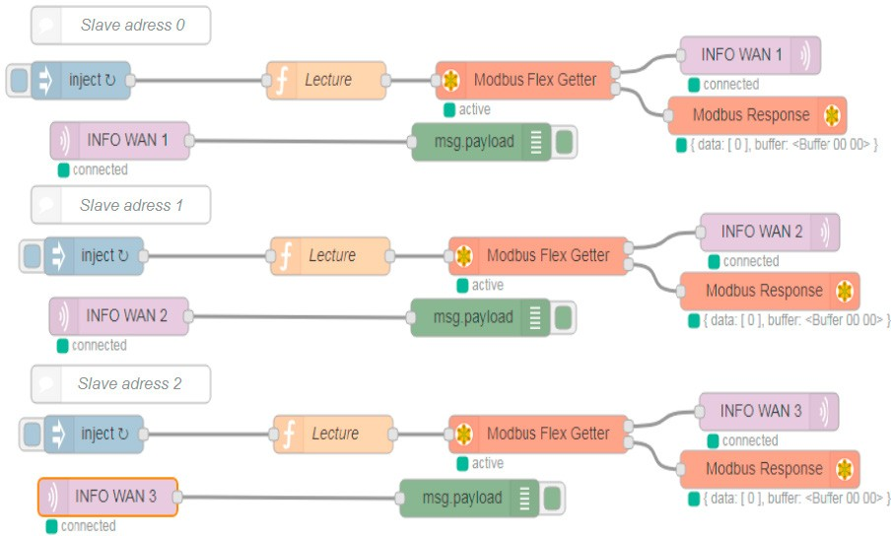

Fig.6. Master/slave communication via MQTT protocol

Industrial connected objects have several advantages, including reducing the cost of deploying and building a controlled workspace. By installing IoT systems on workstations and attaching labels to current products, information on production operations can be collected efficiently and flexibly, and cyber-physical decisions can be made instantly with great accuracy. Figure 7 shows a proposal for plant digitization, which provides intelligent and real-time access to all plant sensors.

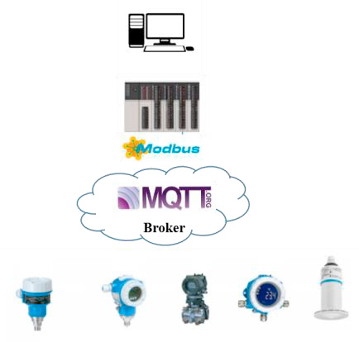

Fig.7.Industrial wireless communication

# Conclusion and perspectives

In automation technology, the introduction of the Internet of Things (IoT) and Cyber Physical Systems (CPS) have revolutionized the industrial world with the introduction of Industry 4.0 technology to create smart factories. In this paper, we presented an industrial communication strategy based on Node-RED using the Modbus industrial protocol and the MQTT communication protocol for M2M industrial communication. This new concept uses wireless communication networks to connect industrial machinery and equipment without the use of binding cables. Thus, the use of wireless sensor networks in industrial environments is undoubtedly beneficial to the development of automation technologies.

As perspectives, we want to broaden communication by adding more slaves by ensuring a distributed and reliable architecture for industrial communications.

# References

1. X. Shen, Z. Wang, and Y. Sun, “Wireless sensor networks for industrial applications,” in *Proceedings of the Fifth World Congress on Intelligent Control and Automation*, vol. 4, pp. 3636-3640, June 2004.
2. A. Ajith Kumar, Knut Ovsthus, Lars Kristensen, “An industrial perspective on wireless sensor network – A survey of requirements,

protocols and chalenges”, IEEE Communications survey and tutorials, 2014.

1. M. Wollschlaeger, T. Sauter, and J. Jasperneite, “The future of industrial communication: Automation networks in the era of IoT and

Industry 4.0,” *IEEE Industrial Electronics. Mag.*, vol. 11, no. 1, pp. 17–27, Mar. 2017.

1. M. Ehrlich, L. Wisniewski, and J. Jasperneite, “State of the art and future applications of industrial wireles sensor networks”, in Proc.

Kommunickation in der Automation (KommA), pp. 80-87, Nov. 2016

1. Shiyoung wang, Jiafu wan, Di Li, Chunhua Zhang, “ Implementing Smart Factory of Industrie 4.0 : An Outlook”, International

Journal of Distributed Sensor Networks Volume 2016, Article ID 3159805, 10 pages.

1. Kun Wang, Yihui Wang, Yanfei Sun, Song Guo, Jinsong Wu “Green Industrial internet of things architecture : an energy-efficient perspective”, IEEE Cpmmunications Magazine – Communications Standards Supplement- December 2016.
2. Jay Lee, Behrad Bagheri , Hung-An Kao, « A Cyber-Physical Systems architecture for Industry 4.0-based manufacturing systems », Manufacturing Letters 3 (2015) 18–23.
3. Julien Minerauda,, Oleksiy Mazhelisb, Xiang Su, Sasu Tarkoma, « A gap analysis of Internet-of-Things platforms », Computer Communications, Special issue on the Internet of Things: Research challenges and SolutionsMarch 11, 2016.